INDEX

Topics Page No.

1. Boolean Algebra 2

2. Canonical and Standard Forms 5

3. Logic gates 8

4. Combinations of logic gates 13

5. Universal Gates 16

6. .Gate Conversions 17

7. Boolean Expression for logic Gates 18

8. Simplification of Boolean Expressions-Algebraic method 20

9. Karnaugh Map 20

10. Tabulation Map 24

Boolean algebra
A set of rules formulated by the English mathematician George Boole describe certain propositions whose outcome would be either true or false. With regard to digital logic, these rules are used to describe circuits whose state can be either, 1 (true) or 0 (false).

Boolean algebra is similar to any other mathematical system. A mathematical system consisting of a set of elements B, two binary operations (+) and (.) an equal sign (=) to indicate equivalence of expressions and parenthesis to indicate the ordering of the operations is called Boolean algebra.

Boolean algebra is used primarily by design engineers. Using this system, they are able to arrange logic gates to accomplish desired tasks. Boolean algebra also enables the engineers to achieve the desired output by using the fewest number of logic gates.

For the formal definition of Boolean algebra E V Huntington introduced some postulates in 1904 .This is called Huntington postulates.

Postulates
1. Commutative Law
(a) A + B = B + A
(b) A B = B A
2. Distributive Law
(a) A (B + C) = A B + A C
(b) A + (B C) = (A + B) (A + C)
3. Identity Law
(a) A + 0 = A
(b) A .1 = A
4. Redundance Law
(a) A + A B = A
(b) A (A + B) = A
5. Compliment
a) A+A’=1
b) A.A’=0

Boolean Theorems

1. Associate Law
(a) (A + B) + C = A + (B + C)
(b) (A B) C = A (B C)

2. (a)
(b)

3. a) 1 + A = 1
proof:
A + 1
A + (A + A' )
A + A' =1
(b) 1 A = A (by Duality)
4.
(a)
(b)
5. De Morgan's Theorem
(a)
(b)

6. Law of Involution
(A’)’=A

Duality Principle
Any algebraic equality derived from the axioms of Boolean algebra remains true when the operators OR and AND are interchanged and the identity elements 0 and 1 are interchanged. This property is called the duality principle.

For example,
x + 1 = 1
x * 0 = 0 (dual)
Because of the duality principle, for any given theorem we get it's dual for free.
Consider the following examples
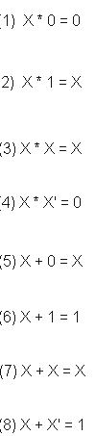

Two valued Boolean algebra
A two valued Boolean algebra is defined on a set of two elements, B= {0,1}, with rules for the two binary operators + and . as shown in the following table.

x y | x.y
0 0  0 1  1 0  1 1 | 0  0  0  1
x y | x+y
0 0  0 1  1 0  1 1 | 0  1  1  1
x | x’
0  1 | 1  0
Huntington postulates are valid for the set B= {0, 1} and the two binary operators.
Boolean Functions
Boolean expressions or formulas are constructed by connecting the Boolean constants and variables with Boolean operations. Boolean expressions are used to describe Boolean functions. For example, if the Boolean expression (x’+y)z is used to describe the function f, then this is written as
f(x,y,z)=(x’+y)z OR f= (x’+y)z
For a given value of variables, the function can be either 0 or 1.
The function f is equal to 1 if x=0/1 y=1 and z=1
Boolean function may also be represented in a truth table. To represent a function in a truth table, we need a list of the 2^{n} combinations of the 1’s and 0’s of the n binary variables, and a column showing the combinations for which the function is equal to 0 or 1.
Truth table for the above function f
x y z | f
0 0 0  0 0 1  0 1 0  0 1 1  1 0 0  1 0 1  1 1 0  1 1 1 | 0  1  0  1  0  0  0  1

Categorization of Boolean expression based on their structure
- Normal formulas/ Standard form.
Consider the four -variable Boolean expression
f(w,x,y,z) =x’+wy’+w’y’z
A literal is defined as each occurrence of either a complimented or an uncomplimented variable in a describing formula. Therefore the above equation consists of six literals. A product term is defined as either a literal or a product of literals. The above equation contains three product terms, namely x’,wy’ w’y’z’ . A Boolean formula that is written as a single product term or as a sum of product terms said to be in sum of products form or disjunctive normal form and is called disjunctive normal formula. Sum-of-Products Boolean expression are a combination of AND statements and OR statements.

Consider another Boolean expression
f(w,x,y,z)= z(x+y’)(w+x’+y’)
The expression consists of six literals. A sum term is defined as either a literal or sum of literals. The above equation consists of three sum terms, namely z, (x+y’), (w+x’+y’). A Boolean formula which is written as a single term or as a product of sum terms is sais to be in product of sum forms or conjunctive normal form and is called conjunctive normal formula. The above equation is an example of conjunctive normal formula.

Conversion between the two forms is done by application of DeMorgans Laws

Example : Show that (X.Y' + Z).(X + Y).Z = X.Z + Y'.Z

(X.Y' + Z).(X + Y).Z = (X.Y' + Z.X + Y'.Z).Z = X.Y'Z + Z.X + Y'.Z

= Z.(X.Y' + X + Y') = Z.(X+Y')
2. Canonical formulas
This is another way to represent Boolean functions. There are two types of canonical formulas. Minterm canonical formula and maxterm canonical formula.

Minterm Canonical formula
For an expression with N variables, Minterm is the product of N distinct literals where each literal occurs exactly once.
For a two-variable expression, the minterms are as follows

X | Y | Minterm
0 | 0 | X'.Y'
0 | 1 | X'.Y
1 | 0 | X.Y'
1 | 1 | X.Y
For a three-variable expression, the minterms are as follows
X | Y | Z | Minterm | Designation
0 | 0 | 0 | X'.Y'.Z' | m₀
0 | 0 | 1 | X'.Y'.Z | m₁
0 | 1 | 0 | X'.Y.Z' | m₂
0 | 1 | 1 | X'.Y.Z | m₃
1 | 0 | 0 | X.Y'.Z' | m₄
1 | 0 | 1 | X.Y'.Z | m₅
1 | 1 | 0 | X.Y.Z' | m₆
1 | 1 | 1 | X.Y.Z | m₇

Eg: F= x’y’z+xy’z’+xyz=m₁₊m₄+m₇
Maxterm Canonical formula
For an expression with N variables, a maxterm is the sum of N distinct literals where each literal occurs exactly once.
For a two-variable expression, the maxterms are as follows

X | Y | Maxterm
0 | 0 | X+Y
0 | 1 | X+Y'
1 | 0 | X'+Y
1 | 1 | X'+Y'

For a three-variable expression, the maxterms are as follows
X | Y | Z | Maxterm | Designation
0 | 0 | 0 | X+Y+Z | M₀
0 | 0 | 1 | X+Y+Z' | M₁
0 | 1 | 0 | X+Y'+Z | M₂
0 | 1 | 1 | X+Y'+Z' | M₃
1 | 0 | 0 | X'+Y+Z | M₄
1 | 0 | 1 | X'+Y+Z' | M₅
1 | 1 | 0 | X'+Y'+Z | M₆
1 | 1 | 1 | X'+Y'+Z' | M₇

Any Boolean function can be expressed as a product of Maxterms and Sum of Minterms.
Eg: F(x,y,z)= x’y’z+xy’z’+xyz=m₁₊m₄+m₇ =∑(1,4,7)
If we take the complement of F then
F’= (x+y+z’)(x’+y+z)(x’+y’+z’)=M₁.M₄.M₇=Π(1,4,7)

Any Boolean function can be expressed as a product of Maxterms and Sum of Minterms.
is said to have in canonical form.

Manipulation of Boolean formulas
By applying the postulates and theorems of Boolean algebra, it is possible to manipulate a Boolean expression into another form describing the same Boolean function.

- Equation complementation
For every Boolean expression f there is associated a complimentary function f’ in which f’(x₁,x_{2,}……..x_{n})=1 if f(x₁,x_{2,}……..x_{n})=0 and f’(x₁,x_{2,}……..x_{n})=0 if f(x₁,x_{2,}……..x_{n})=1 for all combinations of values of x₁,x_{2,}……..x_{n}.

Eg: f(x,y,z)=x’+yz
f’(x,y,z)=(x’+yz)’=x(y’+z’)(using DeMorgan’s law)

- Equation simplification

One possible way of measuring the simplicity of a Boolean expression is to observe the number of literals contained within the formula. By using postulates and theorems of Boolean algebra we can simplify the expression.
Consider the expression
(x+xy)(x’+y)+yz) consistingof seven literals. It is simplififed as follows:

(x+xy)(x’+y)+yz)= x(x’+y) +yz

Logic Gates

Introduction
Logic Gates are circuits made up of transistors, diodes, and resistors. Logic gates process one or more input signals in a logical fashion. Depending on the input value or voltage, the logic gate will either output a value of '1' for ON or a value of '0' for OFF.
Logic gates process signals which represent true or false. Normally the positive supply voltage +V represent true and 0V represents false. Other terms which are used for the true and false states are shown in the table.
Logic states
True | False
1 | 0
High | Low
+Vs | 0V
On | Off
A truth table is a good way to show the function of a logic gate. It shows the output states for every possible combination of input states. The symbols 0 (false) and 1 (true) are usually used in truth tables.
The five common logic gates are :
AND, OR, NOT, NAND, NOR
NOT,AND,and OR gates are basic gates.

NOT GATES
The NOT GATE which is also called an Inverter, is used to invert the logic state of a signal. The output Q is true when the input A is NOT true, the output is the inverse of the input: Q = NOT A
. The symbol for a NOT gate is shown below.
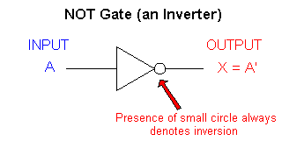
The output of the NOT gate will be the opposite state of the input into the NOT gate. The truth table for a NOT gate is shown below.
Input | Output
0 | 1
1 | 0

Example: The figure below shows the two possible inputs into a NOT gate and the corresponding outputs.

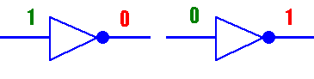

AND GATES
The AND GATE has a logic 1 or high output if all the inputs are high. The symbol and boolean expression for a 3-input AND gate is shown below.
The output Q is true if input A AND input B are both true: Q = A AND B
An AND gate can have two or more inputs, its output is true if all inputs are true.
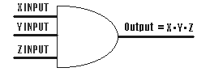
Truth Table
X INPUT | Y INPUT | Z INPUT | OUTPUT
0 | 0 | 0 | 0
0 | 0 | 1 | 0
0 | 1 | 0 | 0
0 | 1 | 1 | 0
1 | 0 | 0 | 0
1 | 0 | 1 | 0
1 | 1 | 0 | 0
1 | 1 | 1 | 1

It doesn't matter if it is a 2-input, 3-input or 4-input AND gate, the only time the output will be high is when all the inputs are high.

Example: The figure below shows the 4 possible inputs into a 2-input AND gate and all the corresponding outputs.
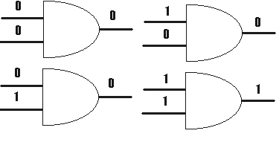

OR GATES

The OR GATE has a logic 1 or high output if any of the inputs are high.
The output Q is true if input A OR input B is true (or both of them are true): Q = A OR B
An OR gate can have two or more inputs, its output is true if at least one input is true. The symbol and Boolean expression for a 3-input OR gate is shown below.
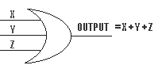
Truth Table
X INPUT | Y INPUT | Z INPUT | OUTPUT
0 | 0 | 0 | 0
0 | 0 | 1 | 1
0 | 1 | 0 | 1
0 | 1 | 1 | 1
1 | 0 | 0 | 1
1 | 0 | 1 | 1
1 | 1 | 0 | 1
1 | 1 | 1 | 1

It doesn't matter if it is a 2-input, 3-input or 4-input OR gate, as long as one of the inputs is high the output will be high. The truth table for a 3-input OR gate is shown below.

Example: The diagrams below shows the 4 possible inputs into a 2-input OR gate and all their corresponding outputs.
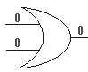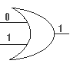

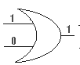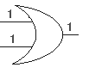

NAND GATES

The NAND GATE is a AND gate with the output inverted. Therefore the outputs of a NAND gate would be the opposites of the outputs of a AND gate. The output is true if input A AND input B are NOT both true: Q = NOT (A AND B)
A NAND gate can have two or more inputs, its output is true if NOT all inputs are true.

The symbol and Boolean expression for a 3-input NAND gate is shown below.

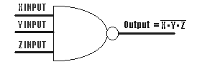

The NAND gate will have a high output as long as all the inputs are not high.

Truth Table
X INPUT | Y INPUT | Z INPUT | OUTPUT
0 | 0 | 0 | 1
0 | 0 | 1 | 1
0 | 1 | 0 | 1
0 | 1 | 1 | 1
1 | 0 | 0 | 1
1 | 0 | 1 | 1
1 | 1 | 0 | 1
1 | 1 | 1 | 0

Example: The image below shows the 4 possible inputs into a 2-input NAND gate and all the corresponding outputs.
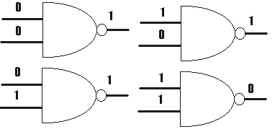

NOR GATES

The NOR GATE is a OR gate with the output inverted. Therefore the outputs of a NOR gate would have the opposite states as the outputs of a OR gate.
The output Q is true if NOT inputs A OR B are true: Q = NOT (A OR B)
A NOR gate can have two or more inputs, its output is true if no inputs are true.
The symbol and Boolean expression for a 3-input NOR gate is shown below.
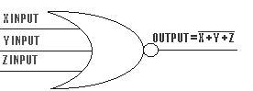

The NOR gate will have a high output as long as all of the inputs are low.

X INPUT | Y INPUT | Z INPUT | OUTPUT
0 | 0 | 0 | 1
0 | 0 | 1 | 0
0 | 1 | 0 | 0
0 | 1 | 1 | 0
1 | 0 | 0 | 0
1 | 0 | 1 | 0
1 | 1 | 0 | 0
1 | 1 | 1 | 0

Example: The image below shows the 4 possible inputs into a 2-input NOR gate and all the corresponding outputs.
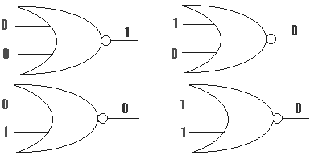

Combinations of logic gates
Logic gates can be combined to produce more complex functions. They can also be combined to substitute one type of gate for another.
For example to produce an output Q which is true only when input A is true and input B is false, as shown in the truth table on the right, we can combine a NOT gate and an AND gate like this:
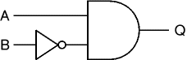
Input A | Input B | Output Q
0 | 0 | 0
0 | 1 | 0
1 | 0 | 1
1 | 1 | 0

Q = A AND NOT B

Example
Some logic families provide a gate known as an AND-OR-INVERT or AOI gate 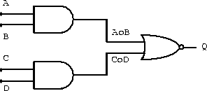

Exclusive OR/ XOR GATES
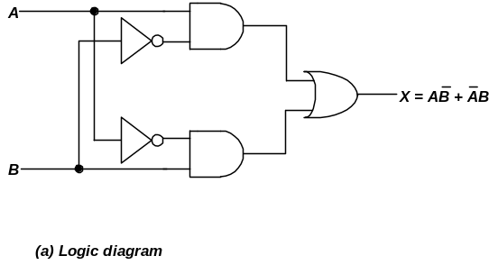

Combinational circuit in the above figure known as exclusive –OR. Because of its wide application it has special symbol.
The XOR GATE is a similar to an OR gate except for the instance when all the inputs are high. With the XOR gate when all the inputs are high the output will be low. In the OR gate the output would be high if all the inputs were high.
The output Q is true if either input A is true OR input B is true, but not when both of them are true: Q = (A AND NOT B) OR (B AND NOT A)
This is like an OR gate but excluding both inputs being true.

The output is true if inputs A and B are DIFFERENT. The symbol and Boolean expression for a 2-input XOR gate is shown below.
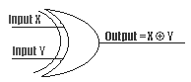

The truth table for a 2-input XOR gate is shown below.

X INPUT | Y INPUT | OUTPUT
0 | 0 | 0
0 | 1 | 1
1 | 0 | 1
1 | 1 | 0

The XOR gate is used frequently in mathematical circuits. An example of the use of a XOR gate is in the half-adder circuit. If either input is high the output of the half-adder needs to be high. But if both inputs are high the output needs to be low and a carry out needs to be generated.

X-NOR (Exclusive-NOR) gate
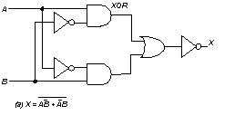

This is an EX-OR gate with the output inverted, as shown by the 'o' on the output.
The output Q is true if inputs A and B are the SAME (both true or both false): Q = (A AND B) OR (NOT A AND NOT B)
EX-NOR gates can only have 2 inputs.

Basic symbol
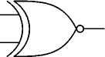

Truth Table
Input A | Input B | Output Q
0 | 0 | 1
0 | 1 | 0
1 | 0 | 0
A XNOR B = A’B’+AB

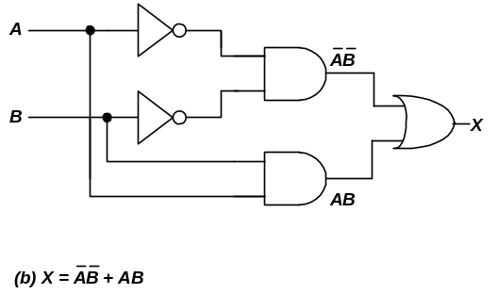

Working out the function of a combination of gates
Truth tables can be used to work out the function of a combination of gates.

For example the truth table below show the intermediate outputs D and E as well as the final output Q for the system shown below.
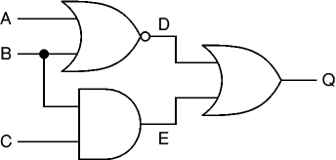

Inputs | Outputs
A | B | C | D | E | Q
0 | 0 | 0 | 1 | 0 | 1
0 | 0 | 1 | 1 | 0 | 1
0 | 1 | 0 | 0 | 0 | 0
0 | 1 | 1 | 0 | 1 | 1
1 | 0 | 0 | 0 | 0 | 0
1 | 0 | 1 | 0 | 0 | 0
1 | 1 | 0 | 0 | 0 | 0
1 | 1 | 1 | 0 | 1 | 1

D = NOT (A OR B)
E = B AND C
Q = D OR E = (NOT (A OR B)) OR (B AND C)

UNIVERSAL GATES.

The NAND and NOR gates are called universal gates, because any gate can build by using these two gates.
The universal property of NAND gates
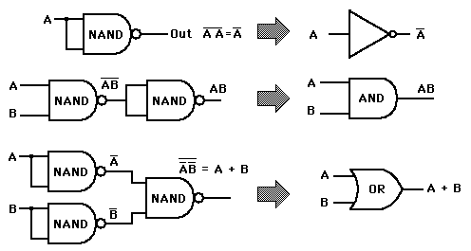

In a similar manner, it can be shown that NOR gates can be arranged to implement any of the Boolean operations.
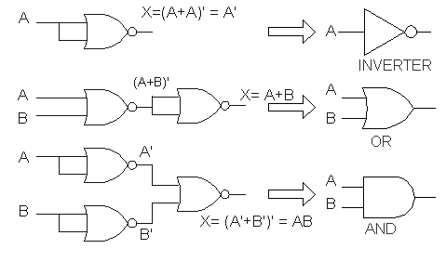

GATE CONVERSIONS
AND Gate logic can be converted to OR Gate logic by inverting all the inputs and outputs of a AND Gate. On the circuit diagram the inversion process is represented by a bubble.

Shown below is the process in converting AND Gate Logic to OR Gate Logic.
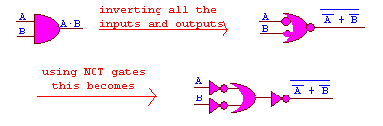
Example: NAND Gate Logic to OR Gate Logic.
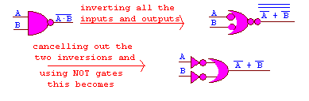

Boolean Expressions for Logic Circuits
A Boolean equation is a mathematical representation of a logic circuit using standard Boolean terms. All the logic gates (AND, OR, NAND, NOR, etc) can be represented by a Boolean expression. Most logic circuits consist of multiple logic gates. A single Boolean equation can be used to represent these logic circuits.
Any logic circuit may be completely described using the Boolean operations, because the OR gate, AND gate, and NOT circuit are the basic building blocks of digital systems.
This is an example of the circuit using Boolean expression:
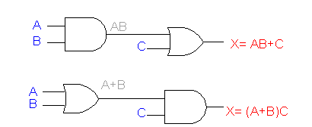
If an expression contains both AND and OR operations, the AND operations are performed first (X=AB+C, AB is performed first), unless there are parentheses in the expression, in which case the operation inside the parentheses is to be performed first (X=(A+B)+C : A+B is performed first).
Whenever an INVERTER is present in a logic-circuit diagram, its output expression is simply equal to the input expression with a prime (') over it.
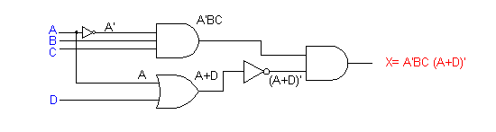

Evaluating Logic Circuit Outputs
Once the Boolean expression for a circuit output has been obtained, the output logic level can be determined for any set of input levels.
These are two examples of the evaluating logic circuit output.
Consider the above circuit,
Let A=0, B=1, C=1, D=1

X = A'BC (A+D)'
= 0'*1*1* (0+1)'
= 1 *1*1* (1)'
= 1 *1*1* 0
= 0

Let A=0, B=0, C=1, D=1, E=1

X = [D+ ((A+B)C)'] * E
= [1 + ((0+0)1 )'] * 1
= [1 + (0*1)'] * 1
= [1+ 0'] *1
= [1+ 1 ] * 1
= 1
In general, the following rules must always be followed when evaluating a Boolean expression:

1. First, perform all inversions of single terms; that is, 0 = 1 or 1 = 0.
2. Then perform all operations within parentheses.
3. Perform an AND operation before an OR operation unless parentheses indicate otherwise.
4. If an expression has a bar over it, perform the operations of the expression first and then invert the result.

Determining Output Level from a Diagram
The output logic level for given input levels can also be determined directly from the circuit diagram without using the Boolean expression.
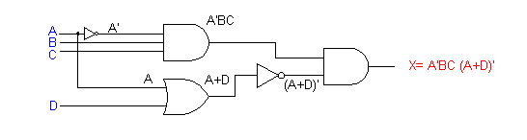

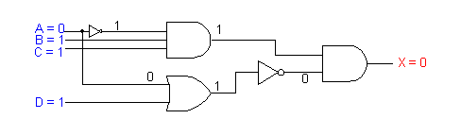
Implementing Circuits from Boolean Expression
If the operation of a circuit is defined by a Boolean expression, a logic-circuit diagram can he implemented directly from that expression.
Suppose that we wanted to construct a circuit whose output is y = AC+BC' + A'BC. This Boolean expression contains three terms (AC, BC', A'BC), which are ORed together. This tells us that a three-input OR gate is required with inputs that are equal to AC, BC', and A'BC, respectively.
Each OR-gate input is an AND product term, which means that an AND gate with appropriate inputs can be used to generate each of these terms. Note the use of INVERTERs to produce the A' and C' terms required in the expression.
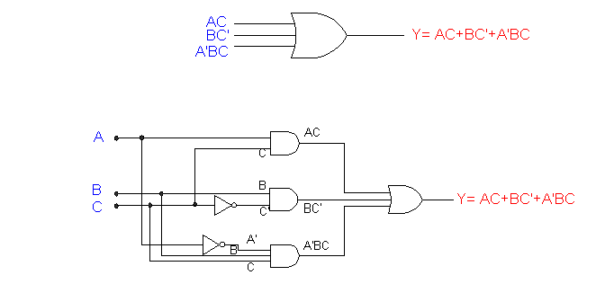

Simplification of Boolean Expressions

Algebraic method

Map method

Tabulation Method

1. Algebraic method

This method is depending on the thorough knowledge of the Boolean algebra. Expression can be simplified by using Postulates and Theories of Boolean algebra.

Eg: Prove the following.

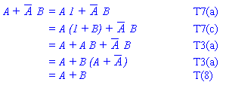

2. KARNAUGH MAPS
This is a method of determining the prime implicants of a Boolean function was developed by Veitch and modified by Karnaugh. The Karnaugh map (K map) provides a systematic method for simplifying a Boolean expression or a truth table function. This method provides a diagrammatic representation of a Boolean function. This representation is called Map. When used properly, the K map will produce the simplest SOP or POS expression possible. Familiarity with the law and rules of Boolean algebra is not required. Instead, simplification is done graphically using the K mapping technique.
The K map is a table consisting of N = 2^{n} cells, where n is the number of input variables. For a SOP expression each cell represents one particular combination of the variables in product form. The table format is such that there is a single variable change between any adjacent cells. This is the characteristic the will determine adjacency. To illustrate the above points let us consider an example where n = 2 and N = 4. Assuming the input variable are A and B then the K map illustrating the four (4) possible variable combinations is show below
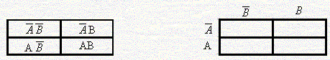
Two variable K map format
If we extend our example to consider the case where n = 3 and N = 8 then assuming that our input variables are A, B and C the associated K Map.
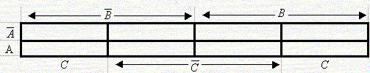
Three Variable K-Map

Simplifying using the K-Map
To simplify a Boolean expression (SOP form) using a K map, first identify all the input combinations that produce an output of logic level 1 and place them in their appropriate K map cell. Consequently, all other cells must contain zero (0). Second, group the adjacent cells that contain 1 in a manner that maximizes the size of the groups but also minimizes the total number of groups. All 1’s in the output must be included in a group even if the group is only one cell. Third, as each SOP term represents an AND expression, each (AND) grouping is written with only the input variables that are common to the group. Finally, the simplified expression is formed by ORing each of the (AND) groups.
The rules for reducing Karnaugh Maps are as follows:
- All of the 1's in the Karnaugh Map are called minterms.
- The 1's can be reduced in groups of 2, 4 & 8.
- Minterms that are next to each other horizontally or vertically, can be grouped together.
- Minterms that have been grouped in a Karnaugh Map, can be reduced to the boolean terms that are common with all the terms in the group.
- Minterms that cannot be grouped together, cannot be reduced.
- You may use a minterm for grouping more than once.
All 1's must be accounted for.
To illustrate lets consider the function whose truth table and K map are illustrated in the following figure.
Input |  |  | Output
A | B | C | X
0 | 0 | 0 | 0
0 | 0 | 1 | 0
0 | 1 | 0 | 0
0 | 1 | 1 | 1
1 | 0 | 0 | 0
1 | 0 | 1 | 0
1 | 1 | 0 | 1
1 | 1 | 1 | 1
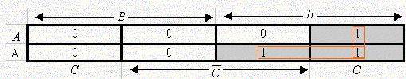
Examination of the K map, the simplified expression for is.

Consider the expression Z = f(A,B) = + A + B plotted on the Karnaugh map
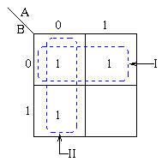

Example: Determine the Karnaugh Map and reduced Boolean equation for the truth table shown below:
C | B | A | OUTPUT
0 | 0 | 0 | 1
0 | 0 | 1 | 1
0 | 1 | 0 | 1
0 | 1 | 1 | 1
1 | 0 | 0 | 1
1 | 0 | 1 | 0
1 | 1 | 0 | 0
1 | 1 | 1 | 0

Without reduction the Boolean Equation for the above truth table is:

Y = A'B'C' + AB'C' + A'BC' + ABC' + A'B'C

Each minterm corresponds to an instance in the truth table when the output is high.
The Karnaugh Map for the above truth table, with the allowed groupings are shown below:
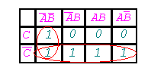
The map shows two groupings that cover each minterm. Each of these groupings will reduce to one term.
The two terms, that are grouped together A'B'C & A'B'C' reduces to A'B'. This is because A' and B' are common to both terms.
The four terms A'B'C' & A'BC' & ABC' & AB'C' that are grouped together reduces to C'. This is because C' is the only input common to all four terms.
Therefore the Boolean expression Y = A'B'C + A'B'C' + A'BC' + ABC' + AB'C' reduces to
Y = A'B' + C'

Don’t Care States
Truth table specifications for a logic function may not to include all possible combinations of the input binary digits for the input variables, yet they may still be complete specifications of the logic function for the prescribed application. In these situations certain input combinations will not occur due to the nature of the application. When the input combinations are irrelevant or cannot occur, the output states are in the Truth table and the K map are filled with an X and are referred to as don’t care states.
When simplifying K maps with don’t care states, the contents of the undefined cells (1 or 0) are chosen according to preference. The aim is to enlarge group sizes thereby eliminating as many input variables from the simplified expression as possible. Only those X’s that assist in simplifying the function should be included in the groupings. No additional X’s should be added that would result in additional terms in the expression.
3. Tabulation Method OR QUINE-McCLUSKEY MINIMIZATION
Using K-maps to find the minimized two-level form of a function is difficult for functions of more than 4 variables and nearly impossible for functions of more than 6 variables because it's hard to visualize and spot patterns in multidimensional space.
The tabulation method which is also known as the Quine-McCluskey method is particularly useful when minimising functions having a large number of variables.
The method involves two steps:
- Finding all prime implicants of the function.
- Use those prime implicants in a prime implicant chart to find the essential prime implicants of the function, as well as other prime implicants that are necessary to cover the function.
1. Find the prime Implicant
- The expression is represented in the canonical SOP form if not already in that form.
- The function is converted into numeric notation.
- The numbers are converted into binary form.
- The minterms are arranged in a column divided into groups.
- Begin with the minimization procedure.
  - Each minterm of one group is compared with each minterm in the group immediately below.
  - Each time a number is found in one group which is the same as a number in the group below except for one digit, the pair numbers is ticked and a new composite is created.
  - This composite number has the same number of digits as the numbers in the pair except the digit different which is replace by an "x".
- The above procedure is repeated on second column to generate a third column.
- The unchecked terms form the prime implicants.
2. Construct the PI table to find the essential prime implicants.
A raw for each prime implicant and a column for each minterm.
- The next step is to identify the essential prime implicants which can be done using a prime implicant chart.
  - Where a prime implicant covers a minterm, the intersection of the corresponding row and column is marked with a cross.
  - Those columns with only one cross identify the essential prime implicants these prime implicants must be in the final answer.
  - The single crosses on a column are circled and all the crosses on the same row are also circled, indicating that these crosses are covered by prime implicants selected.
  - Once one cross on a column is circled, all the crosses on that column can be circled since the minterm is now covered.
  - If any non-essential prime implicant has all its crosses circled, the prime implicant is redundant and need not be considered further.
- Next, a selection must be made from the remaining nonessential prime implicants, by considering how the crosses not circled can best be covered.
  - One generally would take those prime implicants which cover the greatest number of crosses on their row.
  - If all the crosses in one row also occur on another row which includes further crosses, then the latter is said to dominate the former and can be selected.
  - The dominated prime implicant can then be deleted.
Example
Consider the function: Z = f(A,B,C) = + C + A + AC
To make things easier, change the function into binary notation with index value and decimal value. Index indicates the number of 1s contained in the term.
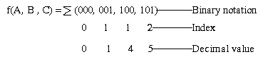
Tabulate the index groups in a column and insert the decimal value alongside.
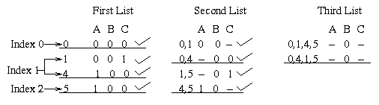
From the first list, we combine terms that differ by 1 digit only from one index group to the next. These terms from the first list are then seperated into groups in the second list. Note that the ticks are just there to show that one term has been combined with another term. From the second list we can see that the expression is now reduced to: Z = + + C + A
From the second list note that the term having an index of 0 can be combined with the terms of index 1. Bear in mind that the dash indicates a missing variable and must line up in order to get a third list. The final simplified expression is: Z = .
Consider another example.
Consider the function f(A, B, C, D) = (0,1,2,3,5,7,8,10,12,13,15), note that this is in decimal form.
(0000,0001,0010,0011,0101,0111,1000,1010,1100,1101,1111) in binary form.
(0,1,1,2,2,3,1,2,2,3,4) in the index form.
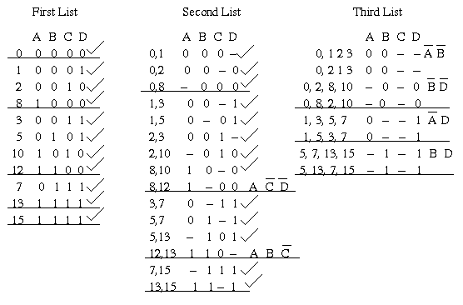
The prime implicants are: + + D + BD + A + AB
The Prime implicant chart is used to remove redundant prime implicants. A grid is prepared having all the prime implicants listed at the left and all the minterms of the function along
the top. Each minterm covered by a given prime implicant is marked in the appropriate position.
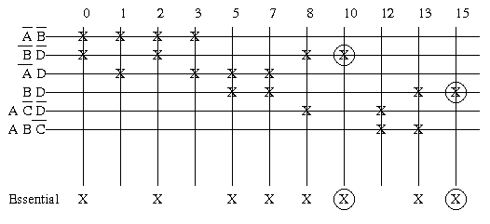
From the above chart, BD is an essential prime implicant. It is the only prime implicant that covers the minterm decimal 15 and it also includes 5, 7 and 13. is also an essential prime implicant. It is the only prime implicant that covers the minterm denoted by decimal 10 and it also includes the terms 0, 2 and 8. The other minterms of the function are 1, 3 and 12. Minterm 1 is present in and D. Similarly for minterm 3. We can therefore use either of these prime implicants for these minterms. Minterm 12 is present in A and AB, so again either can be used.
Thus, one minimal solution is: Z = + BD + + A

